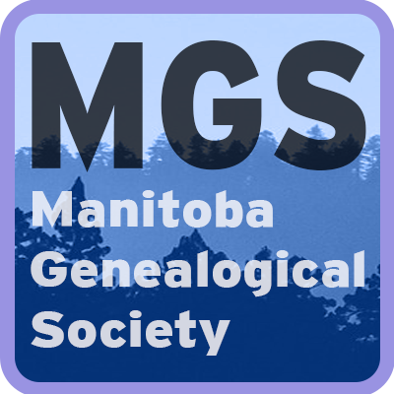

Manitoba Genealogical Society
A Guide to Transcribing Cemetery Records

Table of Contents

MGS Cemetery Transcripts 3
Synopsis of Transcribing Steps 4
Planning and Preparation 5
Field Recording 8
Completing the Spreadsheet 11
Appendix 18
Appendix 1 18
Appendix 2 23

Copyright © 2023
All rights reserved. No part of this book
may be reproduced in any form without
permission in writing from the publisher.
Publisher by:
Manitoba Genealogical Society
Cemetery Committee
Unit “E”
1045 St. James Street
Winnipeg, MB
R3H 1B1

MGS Cemetery Transcripts
Cemetery transcriptions refer to the systematic survey of a cemetery and the process of recording and documenting the location of and the inscriptions found on gravestones or other markers in a cemetery.
Cemetery transcriptions can serve as valuable resources for genealogists, historians, and others who are interested in researching family histories or the history of a particular area. Transcriptions can provide information about the names, birth and death dates, and familial relationships of individuals buried in a cemetery, as well as, any other inscriptions or epitaphs found on the markers. They can also offer insights into local customs, religious beliefs and cultural practices.
Transcribing cemeteries involves gathering information about the cemetery and the interred remains. Cemetery information includes the current and official name of the cemetery, its location, ownership history and current condition. Records of interred remains include grave marker inscriptions, sexton records (the person or organization responsible for keeping records): previous transcriptions, burial records, church records, vital statistics records, obituaries and memorials. To gather this information, one can record all inscriptions on each grave marker using a digital camera or cellphone, type them into a spreadsheet, and contact funeral homes or the Municipal office to find the sexton of the cemetery. Archived copies of old newspaper obituaries, websites like FindaGrave, or CanadaGenWeb’s Cemetery Project, and local history books can also provide additional information on interred persons. Church records can give additional details about funeral services performed. Citation of sources for information is crucial.
Cemetery transcriptions can be conducted using a variety of methods, including taking photographs of the markers, or simply copying down the information found on the markers. The information on grave markers, monuments, and other markers found in a cemetery will need to be recorded in the MGS spreadsheet.
The Manitoba Genealogical Society (MGS) has a wealth of information about Manitoba cemeteries. Since 1978, volunteers from MGS and its branches have visited over 1700 cemeteries in Manitoba. They have recorded the exact inscriptions (called transcribing) on every grave marker in each cemetery (name, birth/death date, and other wording). All data was double checked by another volunteer so the information is fairly accurate. This information has been computerized and added to the Manitoba Name Index (MANI). A Cemetery Transcript document has been created and available for viewing at MGS or purchasing a copy for your use at home.
MGS has indexed its cemetery transcriptions by the name of the Rural Municipality (RM) in which the cemetery is located, and in a few cases by the city name (i.e. Brandon and Winnipeg). A knowledge of which RM a particular town, village, or homestead is located in can be helpful to locate a cemetery. To learn more about Manitoba RMs, visit the Government of Manitoba Municipal Relations or the Association of Manitoba Municipalities.

Synopsis of Transcribing Steps
Transcribing cemeteries involves recording the information on grave markers, monuments, and other markers found in a cemetery. The following are the steps to transcribe cemeteries:
- Choose a cemetery: Choose a cemetery that you want to transcribe. Make sure you have permission to access the cemetery and that it is safe to visit.

- Prepare: Before you begin transcribing, make sure you have the necessary tools such as a notebook, pen, and a camera. Dress appropriately for the weather conditions, wear comfortable shoes, and carry water, snacks, insect repellant, etc.

- Locate grave plot: Begin by walking around the cemetery to locate graves. You can use a map of the cemetery, if available, or sketch a quick map of the layout of the cemetery.

- Take pictures: Take pictures of each grave, including the surrounding area, to document the condition of the plot, its location within the cemetery, and the inscription on the grave marker(s).

- Record plot information: Record the information on each plot. This typically includes the name of the deceased, the date of birth and death, and any additional information provided on the grave marker. It, also, includes recording other types of markers on the plot, as well as, their inscriptions.

- Organize your notes: Organize your notes and pictures by plot or section of the cemetery. Use a notebook or spreadsheet to keep track of the information.

- Share your findings: Provide MGS with a digitized copy of the spreadsheet and any photographs you took.

- Respect the cemetery: Respect the cemetery and its occupants. Do not damage any markers or disturb any graves. Leave the cemetery as you found it.

Planning and Preparation
Taking the time to plan and prepare for your trip to the cemetery will help you to transcribe the cemetery in an efficient manner and with fewer problems.
- The cemetery – refers to information about the cemetery itself. This is the current (and official) name of the cemetery, the exact location of the cemetery, directions to the cemetery, who owns the cemetery or who owns the land the cemetery is on, history of the cemetery (prior names, when it was established, etc.) and the current condition of the cemetery.

- The records of the interred – refers to the records of persons buried in the cemetery. These usually include grave marker inscriptions, but can also include sexton records, vital statistics, newspaper obituaries, previous transcriptions, church records, etc.

- Choose a Cemetery:

  - Cemetery

    - Document the type of cemetery. Each type of cemetery is designed and organized to reflect the religion, culture, traditions, and habits of the community it serves. Types of cemeteries:
      - Family/Homestead Burial Site are privately held parcels of land specifically designated for the burial of members of the same family. Family cemeteries were commonly used throughout the 19th and 20th centuries.;
      - Municipal Cemeteries re owned by the local city/town or municipality. The upkeep and maintenance usually fall under the supervision of the public works department. The cemetery serviced (opening of graves, setting of the vaults and performance of burial services are outsourced the funeral home. Municipal, or public, cemeteries may be self-funding or subsidized by the local government;
      - Religious Cemeteries are owned and operated by a religious group or order to serve a specific religious community. Religious cemeteries may have religious restrictions dictating the religious beliefs of individuals buried within the cemetery. Religious cemeteries vary in their level of required observance and practice;
      - Scattering Gardens are a cemetery or a designated area in a cemetery where you may scatter cremated ashes. The cemetery often posts a wall or other memorial marker inscribing details about each person whose ashes rest there. A memorial bench or plaque may also record the person(s) details.
      - Veterans Cemeteries are a cemetery or a designated area in a cemetery and is limited to those individuals who qualify for veteran funeral and burial program.

    - Find out who has legal jurisdiction over the cemetery property and get permission to be on the grounds recording the data, taking pictures, and trimming vegetation from the grave markers. Offer them a copy of the completed work;

    - If the cemetery is abandoned, attempt to find out who owns the land the cemetery is on and obtain permission from the legal owner to be on the property;

    - List the process/steps of receiving permission before going to the cemetery;

    - To find who is the owner/guardian of the cemetery and their contact information start by contacting the closest funeral home(s) in the area, as they may know. You can also contact the Municipal Office as they may know the land owner of every parcel and have their contact information;

    - Request access to the burial register and permission to photograph it. It helps to identify the location of plots and update the cemetery spreadsheet prior to walking the cemetery. It is a useful practice to update the cemetery spreadsheet with this information prior to walking the cemetery;

    - Locate a burial map, if available, from the cemetery office/caretaker or the municipality. The section, section part, row, plot numbers may already be assigned;

    - If no map is available, then print off an online map of the cemetery (i.e. GoogleMap). It might help in familiarizing yourself with the cemetery layout;

    - Prepare sketch maps for use in the cemetery. This will help in the completion of the Transcription document; and

    - Take the old transcript with you to the cemetery and re-read the way it was set up.

  - Record of the Interred

    - Cemeteries operated by churches usually have additional records on funeral services performed at their location. Request access to church records and permission to transcribe or photograph them;

    - Request the latest transcript/spreadsheet from MGS;
      - Review the spreadsheet. It contains five tabs:
        - Instructions – Provides instructions on the data to collect and how to enter this data in the spreadsheet;
        - Re-Read – This is the sheet you will use to enter new burial transcriptions;
        - Transcription – Provides the transcriptions collected from previous readings of the cemetery. If you review the data and notice corrections need to be made, enter them in red font;
        - Index – Used by the individual creating the new Transcript document; and
        - Upload – Used by the individual uploading the data to the Manitoba Name Index (MANI), a searchable online database found on the MGS website.

      - Review the old transcript and take a look at how it’s organized (i.e. direction of the reading, location of sections, section parts, rows, grave markers, etc.).

- Prepare:

  - Things to consider taking with you:

    - Bug spray, sunscreen, water, snacks and a phone;

    - Lawn chair to sit on while you are taking a break;

    - Camera or smartphone to take photos (make sure your battery is fully charged);

    - Clipboard, extra paper, pens;

    - Grass Clippers/trowel/gloves, soft brush, whisk/broom to clean the area around the grave marker to make the inscription viewable;

    - Large spray bottle of water, paper towels/cloth to enhance the markings to make the inscription viewable;

    - Flashlight and mirror to help read the inscription;

    - Paper/crayon/pencil to do shading if you can’t read the inscription;

    - A ground marker (coloured stick) for unmarked graves;

    - If taking photos and transcribing the information later to the spreadsheet take a small easel or chalkboard to use as a reference marker, and take a picture of the row number before photographing the grave markers in the row;

    - A measuring tape is useful for determining where plots are and for measuring family plots; and

    - A wagon or cart to transport everything as you walk the cemetery.

  - For difficult to read stones:

    - Take a large spray bottle of water and a soft brush. Spray the stone lightly with water. If you still can’t read it, GENTLY brush the water into the creases and look again;

    - Take a digital picture of the stone which later can be digitally enhanced in a photo editing program to aid in reading the stone;

    - It is easier to read stones on a cloudy day than a sunny day; and

    - The use of a flashlight and mirror to redirect the light on the grave marker may aid in reading the stone.

Field Recording
- Record plot information:
Identify the information that should be obtained when reading/re-reading a cemetery.
  - Cemetery:

    - File of Cemetery Information:

Document the cemetery location and description of the cemetery in a directional and historical way:
      - Cemetery Name;
      - Location:
        - Using your phone, document the GPS decimal coordinates at the entrance to the cemetery;
        - Street address;
        - If the cemetery is located at a junction/crossroad, the road numbers should be included; and
        - Rural areas are required to have an address number on their home entrance.
      - Directions on how to reach the cemetery;
        - Start by noting an easily identifiable landmark or highway;
        - Note the mileage between turns; and
        - Try not to use ‘left’ and ‘right’ when describing turns. Instead use ‘north’, ‘south’, ‘east’ or ‘west’.
      - Who owns the cemetery or who owns the land the cemetery is on;
      - Historical Notes on the Cemetery (when and who established the cemetery, prior names);
      - Ethnic and/or religious background of the cemetery;
      - Current condition of the cemetery;
      - Who is the owner or guardian of the records of persons buried in the cemetery, where are the records kept, and whether you had access to view, transcribe, copy or photograph the records;
      - Miscellaneous Comments of Transcription (i.e. Complete Transcription or Re-Read);
      - Map of the Cemetery & Grave Markers within;
      - Other reference sources; and
      - Reference Number (CemID) - supplied by MGS.

  - Monumental Inscription & Burial Details:

    - Location
      - Provide such details as grave location (Section, Section Part, Row, Plot).

    - Shared:
      - If the grave marker is shared indicate this by documenting ‘S1’, ‘S2’, etc.;
      - Many cemeteries allow two or three to be buried in the same plot, usually one casket below, and the other casket or cremation urn placed on top. The grave marker inscription will note two persons. In the “Notes” column use the abbreviation ‘s/w’ (share with) to indicate the person is buried with another; i.e.
        - Entry for John Doe in “Notes” column – ‘s/w Jane Doe’, and
        - Entry for Jane Doe in “Notes” column – ‘s/w John Doe’;
      - If the plot has more than one headstone indicate this by documenting SSSP (separate stone same plot).

    - Type of Stone:
      - To aid in identifying stones please refer to the Type of Grave Markers, a document listing the various types of grave markers with reference pictures (see Appendix 1);
      - If a plot contains more than one marker, such as a headstone, footstone or FHM, document all types of markers in the “Type of Stone” column; and
      - If there is no grave marker record ‘Unmarked’.

    - Inscription:
      - Record all the inscriptions found on the marker line by line;
      - Grave markers that are partially unreadable need to be recorded as such by using a question mark (?) for each character found illegible;
      - When the inscription is in another language, transcribe the inscription in the original language and the translation in the same entry on the spreadsheet. Enter the word, “Translation:” prior to entering the translation;
      - Record not just the name and dates, but also other inscriptions including ‘RIP’, ‘Beloved Mother’, note symbols such as the Masonic symbol, Crucifix symbol, Trade or Occupation emblems, etc., and record the word ‘Photo’ if there is a photo on the grave marker. These other inscriptions tell something about the deceased and can even help other genealogists identify them;
      - Record all words exactly as you see them on the grave marker, do not shorten or correct the spelling of any words. If a person takes a copy of the transcription to the cemetery there should be no discrepancies;
      - Put a forward slash, (/) where each line ends on the stone;
      - For shared stones put a double forward slash (//) between the shared inscriptions and the inscriptions for an individual;
      - Inferred information (information not found on the grave marker, but has been recorded using reference documents) should always be indicated within square brackets, ‘[ ]’;
        - The expansion of abbreviations, i.e. ‘KofC [Knights of Columbus];
        - Marriage date surmised from wedding rings with date, i.e. [married] Oct 25 1947;
      - Make sure to check for data on the back of the grave marker and write [Back] before that data entry;
      - If there is a footstone write [FS] followed by the data;
      - If there is another stone in the same plot write [SSSP] followed by the data; and
      - If there is no grave marker record ‘Unmarked’.

    - Notes:
      - Other information found on the plot, i.e. ‘broken marker’, ‘illegible’, etc.

    - Names:
      - Record names as spelled in the inscription.

    - Birth:
      - Record date of birth as documented in the inscription.

    - Death:
      - Record date of death as documented in the inscription.

    - Pictures:
      - Use of photos can greatly reduce transcription errors as opposed to hand written transcriptions.
      - Take a digital photo of the grave marker;
      - Photos must be clear with no reflections;

    - Burial Register:
      - If you receive access to the Burial Register and receive permission, photograph/transcribe all information found in the record; i.e. plot location, purchaser of plot, name of interred, date of burial, the funeral home that administered the burial, etc.

    - Church Records:
      - If you receive access to the Church and receive permission, photograph/transcribe all information found in this record; i.e. name of deceased, date and place of funeral, date and place of burial, etc.

Completing the Spreadsheet
- Organize your notes:
The spreadsheet is the document the transcriber uses to enter the information about the burials in the cemetery. It is useful to familiarize oneself with the requirements for entering the information in the columns prior to making any entries.
Arranging the transcription entries by location and referencing each by section, section part, row, plot, shared is the preferred and default standard. Sorting the entries this way allows one to note who is buried next or close to an individual which may indicate they were related.
For a large cemetery, record each section on a separate spreadsheet tab.
  - “Re-Read” Spreadsheet Tab

    - This spreadsheet is used to record new burials; and
    - Record entry information in red-coloured font.

  - “Transcription” Spreadsheet Tab

    - This spreadsheet contains burials already transcribed for MGS; and
    - Review the entry information for data errors and make corrections in red-coloured font.
The information to be recorded in both these tabs are the same and are captured under the following column headers:
  - CemID:

    - The cemetery number is assigned by MGS;
    - The number must be entered in a 4-digit format, i.e. ‘0123.

  - Location Column(s):

    - Section
      - Large cemeteries may divide the cemetery into sections for easier location of rows and plots;
      - Enter the section identifier as designated by the cemetery (letters / numbers).
    - Section Part
      - Large cemeteries may further divide the cemetery into section parts for easier location of rows and plots;
      - Enter the section part identifier as designated by the cemetery (letters / numbers);
      - A family plot would be entered in this column.
    - Row
      - The rows are assigned by the cemetery or, in the case of small cemeteries, the transcriber will assign the row numbers;
      - If the transcriber assigns the row number this should be stated in the description section for the cemetery.
    - Plot
      - The plots are assigned by the cemetery;
      - Grave plots range from 30”- 42” (2½ feet - 3½ feet) in width;
      - In the case when burial records are not available to review and obtain the plot number the transcriber will assign plot numbers for each row;
      - To assign plot numbers:
        - The transcriber will measure the distance for known plots (designated by grave markers) to estimate the width of a plot for the cemetery;
        - The transcriber will then assign the number of plots in each row using this measurement.

  - Shared:
    - Record if the plot or grave marker are shared (S1, S2, etc.);
    - Record if the plot has more than one headstone by documenting SSSP

  - Type of Stone:

    - Refer to Type of Grave Markers to determine the type of stone marker and record it here;
    - Maximum 50 characters.

  - SURNAMES:

    - Do not enter information in this column as it is automatically pulled from the SURNAME and MAIDEN NAME columns; and
    - The column is highlighted in blue to indicate this.

  - Inscription:

    - Enter all engravings found on a grave marker, not just the name and dates; i.e. ‘RIP’, ‘Beloved Mother’, ‘photo’ (if there is a photo), ‘engraving of symbols (Masonic, Eastern Star, Legion, etc)’, ‘engraving of a plane’, etc
    - Use a single forward slash “/” to indicate a new line;
    - For shared grave markers use double forward slashes “//” to separate the transcription from information that applies to all the individuals;

  - Notes:

    - Other information found about the plot, i.e. ‘broken marker’, ‘illegible’, etc.;
    - The purchaser of the plot, obtained from the burial register, should be added to the “Notes” section; and

  - Name Columns:

    - If reference documents record a different spelling of the name or provide the full name when the grave marker records only initials add this information in the appropriate column and document the reference in the appropriate column;

    - SURNAME
      - Record all surnames found on the marker or in the Sexton records, except for maiden names;
      - Entry is a single surname which could be hyphenated or two names if the person was known by the double name;
      - For individuals who have more than one surname (such as multiple marriages) enter the alternative surnames separated by a forward slash (/);
      - Surnames should be in uppercase letters (except McBean, MacDonald, etc.);
      - No space after ‘Mc’ or ‘Mac’; and
      - Spaces are allowed after LA, VAN, DE, etc..

    - Prefix
      - Record all prefixes to names found on the marker or in the Sexton records, i.e. Dr, Rev, Mr, Mrs, etc.

    - First Name:
      - Record the first name as found on the marker or in the Sexton records;
      - Should be recorded in mixed case --- the first letter in uppercase and all subsequent letters in lowercase (i.e. Jane); and
      - Put Sr and Jr in brackets following the firstname, i.e. Joe [Sr].

    - Middle Name(s):
      - Record the middle name(s) or intial(s) found on the marker or in the Sexton records; and
      - Should be recorded in mixed case --- the first letter in uppercase and all subsequent letters in lowercase (i.e. Mary).

    - MAIDEN NAME:
      - Record the maiden name found on the marker or in the Sexton records; and
      - Should be recorded in uppercase letters (except McBean, MacDonald, etc.).
      - No space after ‘Mc’ or ‘Mac’; and
      - Spaces are allowed after LA, VAN, DE, etc..

    - Nickname:
      - Record the nickname(s) found on the marker or in the Sexton records.

  - Birth:

    - Record the year of birth found on the marker or in the Sexton records;
    - Record as a 4-digit year, i.e. ‘2023’; and
    - To correct the date a reference is needed (i.e. birth certificate).

  - Death:

    - Record the year of death found on the marker or in the Sexton records; and
    - Record as a 4-digit year, i.e. ‘2023’ and
    - To correct the date a reference is needed (i.e. death certificate).

  - Burial Date:

    - Record as a dd mmm, i.e. ’26 Feb’;
    - Be sure the date is formatted as ”text”, it should not show as ‘26-Feb’ but as ‘26 Feb’; and
    - Record the day and month of burial found in the Sexton records.

  - Event Year:

    - Record the year of burial found in the Sexton records; and
    - Record as a 4-digit year, i.e. ‘2023’.

  - CT Pictures:

    - Enter ‘yes’ if you have a picture or ‘no’ if you don’t.

  - TypeCode:

    - The letters ‘ct’ are required in this column; and
    - Required for uploading to MANI.

  - StatusCode:

    - The word ‘NEW’ is required in this column; and
    - Required for uploading to MANI.

  - References:

    - Every record entry should have a source reference --- grave marker, photo, burial register, church record, Manitoba Vital Statistics, obituary, memorial from online platforms (such as FindaGrave, CanadaGenWeb’s Cemetery Project), etc.);
    - Record which reference sources were used:
        - GRI (Grave Marker Inscription);
        - BR (Burial Register);
        - CR (Church Record);
        - Local History Book (LHB);
        - MB-VS (Manitoba Vital Statistics);
        - Obituary; and/or
        - Online Memorial.

  - Reference Records:

    - Are not mandatory, but are very beneficial towards obtaining sufficient identifying information;

    - Information that may be found in these records are person’s parents, spouse or siblings, person’s occupation, place of birth, last known residence, military affiliation, cause of death;

    - Photos:
      - Label photo file with CemID number, grave marker location, name of individual; i.e.
        - Individual Grave Marker - ct0123_R1P2_DOE, John, and
        - Shared Grave Marker – ct0123_R1P2_DOE, John & Jane (SMITH); and
      - Enter this photo name in the column titled “Photos”;
      - Send the digital copies of photos to MGS and give permission to MGS to use the photos by completing the MGS Photo/Image Copyright Release Form refer to Appendix 2. Also available from the Cemetery Committee at cemetery@mbgenealogy.com.

- Burial Register:
      - It is useful to acquire permission to access the burial register information;
      - This information is used as reference to that found on the grave marker, as well as, to provide missing information or corrections; and
      - Record the information you found in the burial register, i.e. plot location, purchaser of plot, name of interred, date of burial, the funeral home that administered the burial, etc.; and
      - If you receive permission to photograph the burial register then save the photo with the cemetery ID number, cemetery name and burial register page number or individuals name; i.e. ct1234_Riverside Cemetery Burial Register_Page 1 or ct1234_Riverside Cemetery Burial Register_Doe, John.

    - Church Records:
      - It is useful to acquire permission to access the church records;
      - This information is used as reference to that found on the grave marker, as well as, to provide missing information or corrections; and
      - Record the information you found in the church records, i.e. name of deceased, date and place of funeral, date and place of burial, etc.; and
      - If you receive permission to photograph the church records then save the photo with the cemetery ID number, cemetery name and church record page number or individuals name; i.e. ct1234_Riverside Cemetery Church Record_Page 1 or ct1234_Riverside Cemetery Church Record_Doe, John.

    - Local History Book(s):
      - It is useful to acquire information found in the local history books. They can be found at MGS or online through the University of Manitoba Libraries digitalcollections.lib.umanitoba.ca;
      - The information is used as reference to that found on the grave marker, as well as, to provide missing information or corrections; and
      - Provide a link to the online book page(s); or
      - Document the book in the APA Style: author, Title, (edition), publisher, (year published), and page(s) number(s), i.e.
        - Mossey River History Book Committee. Memories "From the Past" Rural Municipality of Mossey River. Friesen Corporation. (1999), pp 114-115.

    - Manitoba Vital Statistics:
      - It is useful to acquire vital statistics records, such as Manitoba’s;
      - The information is used as reference to that found on the grave marker, as well as, to provide missing information or corrections; and
      - Record the information you found in birth, marriage, and/or death records, i.e. type of record: registration number, name, gender, date of birth, date of death, location, age, and name of parents.

    - Obituaries:
      - It is useful to acquire obituaries;
      - They usually record name of deceased, birth and death dates, family members, date and place of funeral, date and place of burial, etc.;
      - This information is used as reference to that found on the grave marker, as well as, to provide missing information or corrections; and
      - Provide a link to the online obituary or a digital file of a printed obituary.

    - Online Memorials:
      - It is useful to acquire online memorials;
      - Check Find a Grave, CanadaGenWeb’s Cemetery Projects, Canadian Headstones, Billion Graves or like websites;
      - This information is used as reference and can provide missing information;
      - Can be used in lieu of taking a photograph of the grave marker if the online memorial has a good quality photograph of the marker; and
      - Provide a link to the online memorial.

  - General Information:

    - MANI will not accept:
      - Extended dash (created when dash followed by space); and
      - Fraction symbols other the ‘1/2’ --- change all other fractions to ‘1/2’.

    - Nun
      - Example from the Winnipeg Free Press (WFP), 01 Sep 2005: SISTER Cecile PAQUIN (SISTER Therese-Elenore);
      - Assuming she was born Cecile PAQUIN and took the name Sister Therese Elenore, transcribe as two entries:
SURNAME Forenames
PAQUIN Cecile
formerly PAQUIN Therese Elenore (SISTER);
      - Do not use SISTER as a surname;
      - If she went by her own name, enter her full name with ‘Sister’ in the Prefix column;
      - If her own name is given, but she went by a different name, transcribe two entries, as noted above;
      - No need to include the order (i.e. S.N.J.M.);
      - At present, entry for Sister Geraldine MacNAMARA on 21 February 1984 is:
SURNAME Forenames
SISTER MacNAMARA Geraldine Maureen Chris
The rules above would suggest this one entry:
SURNAME Prefix Forename
MacNAMARA Sister Geraldine Maureen Chris;
    - Don’t capitalize ‘mar’ or ‘wed’ when this refers to marriage as it can be confused with Wednesday or March or the name Mar(y); and

    - When copying text, make sure ‘rn’ (letters r and n) isn’t turned into ‘m’ (single letter m).

- Share your findings:

  - Documents to be provided to MGS in digital format:

    - Cemetery write-up;
      - Location of cemetery,
      - History of cemetery,
      - Owner/guardian of cemetery,
      - Owner/guardian of sexton records, and
      - Map of Cemetery;
    - Spreadsheet;
    - Photographs;
    - MGS Photo/Image Copyright Release Form

  - Inform MGS if a copy of the completed work is to be provided to the owner/guardian of the cemetery.

- Respect the cemetery:

  - Be careful not to damage any stones;

  - Be respectful if you see family members visiting a stone or if you see a funeral taking place.

Appendix

Appendix 1

TYPE OF GRAVE MARKERS

Name | Description | Picture
Altar Tomb | A solid, rectangular, raised tomb or grave marker resembling ceremonial altars of classical antiquity and Judeo-Christian ritual. | 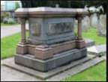
Baby/Child Marker | Small vertical slab, often with lamb on top. | 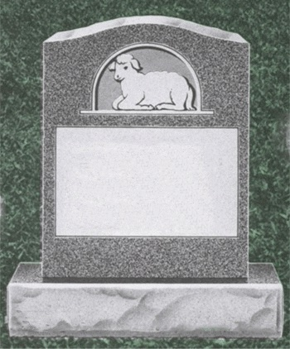
Bevel | Rise a few inches above the ground and have a sloping shape. | 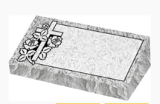
Cenotaph | A monument to someone buried elsewhere, especially one commemorating people who died in a war. A cenotaph may look exactly like any other grave marker and located over an empty plot. | 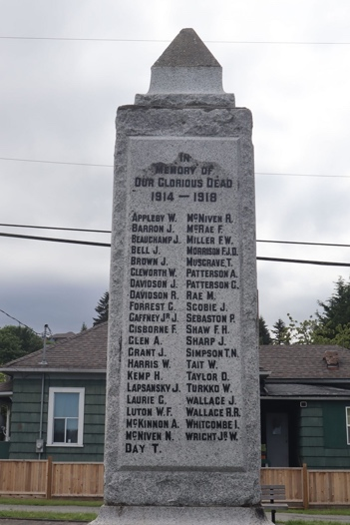
Columbarium | A building for cremation urns (from many families) in separate drawers or compartments. | 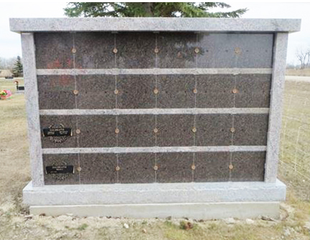
Column | Round, often have transcriptions all around (though not always transcribed). | 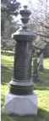
Emerging Stone | A type of gravestone where one portion of the stone has been fully  carved, while another portion remains undressed or only partially dressed, giving the impression of a stone that has been incompletely carved. | 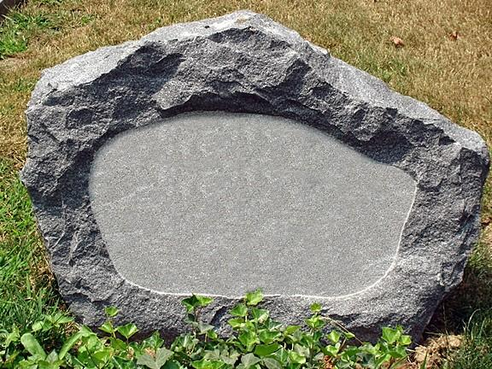
FHM | Funeral Home Marker | 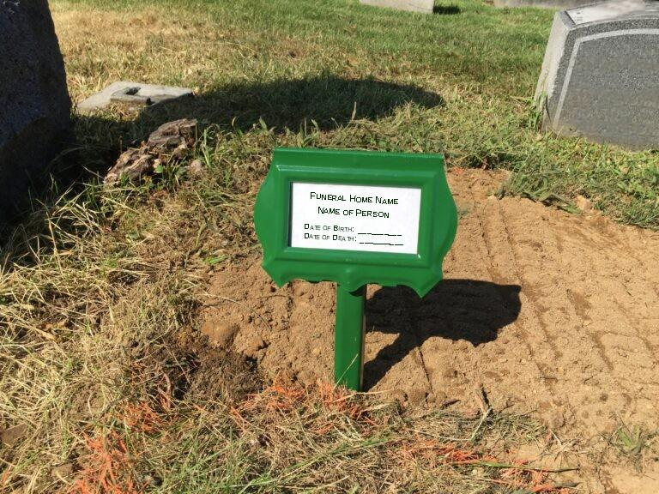
Flat Slab | Level to ground, some might be partly buried or covered with grass; any grave marker that is essentially a thin, flat piece. Slabs can be of any material but usually are of stone, concrete, or wood. | 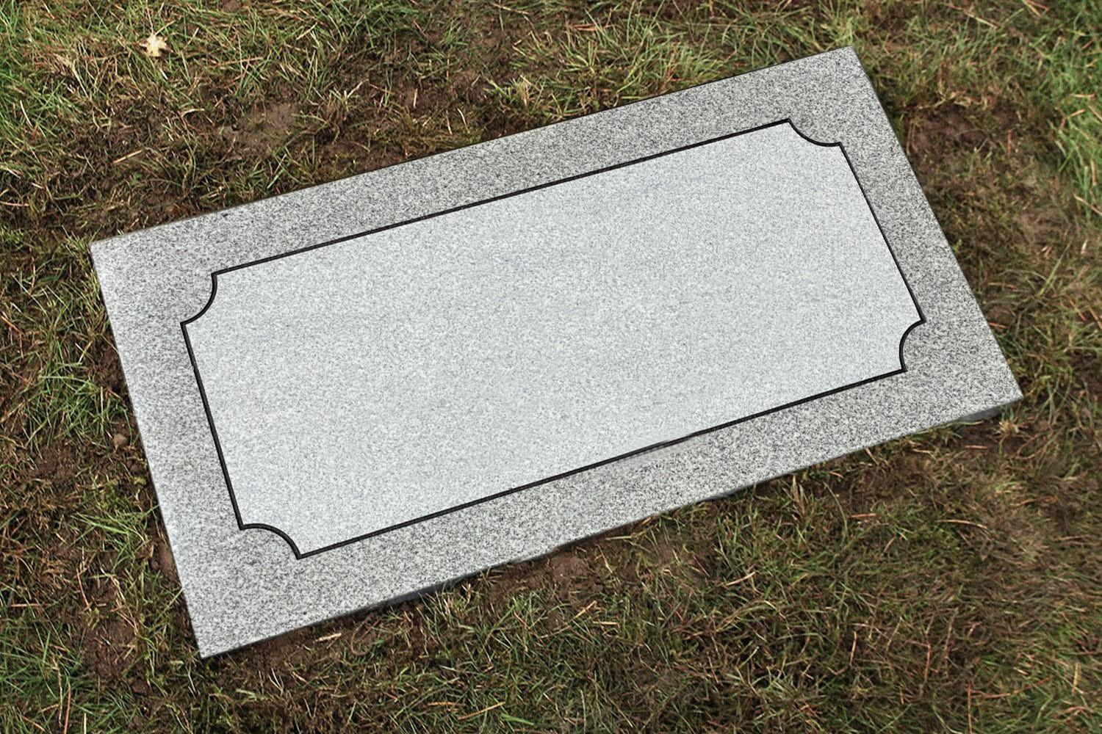
Footstone | A flat, slab-like stone grave marker placed at the foot end of a grave; footstones, are used in conjunction with headstones and usually are considerably smaller and less ornate, often bearing only initials as inscriptions. | 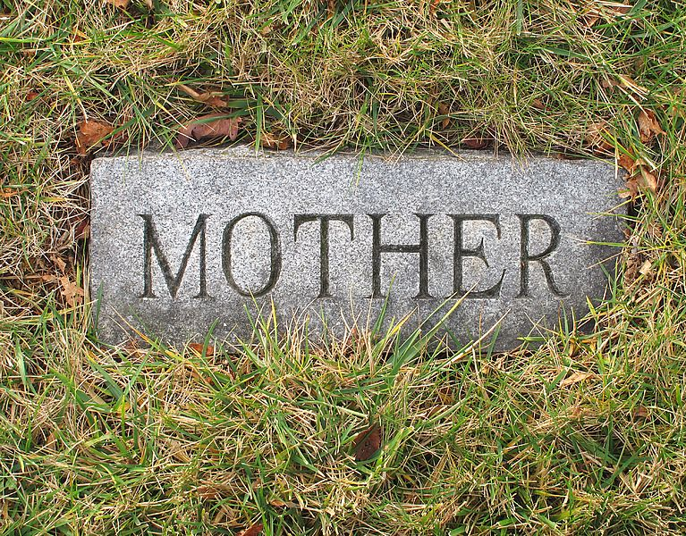
Ledger Stone | A memorial stone laid prone and covering all or most of the grave. | 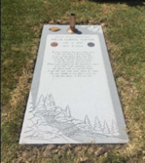
Mausoleum | A building for housing bodies or cremation urns (from many families) in separate drawers or compartments. | 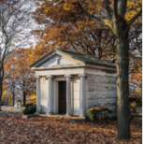
Memorial Cairn | An object, often large and made of stone, that is erected to honour a famous person or a group of people. | 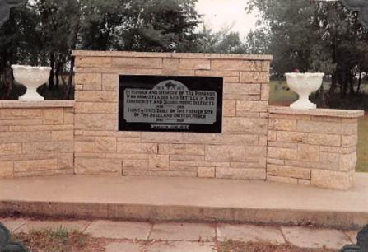
Military | Usually vertical slab with Military cross or insignia (from DVA). | 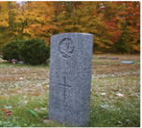
Monument | Large stone, often with initial monogram at top, includes many names. | 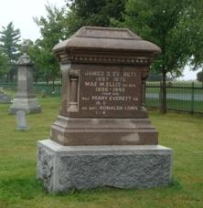
Obelisk | A gravestone that is tall, slender, square in cross-section, and pointed at the top. | 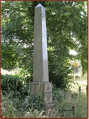
Pillar | Square, often have transcriptions on all 4 sides (though not always transcribed). | 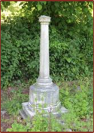
Raised Slab | Flat, but elevated on small base so shouldn’t get buried/covered. | 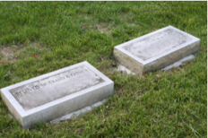
Scattering Garden Plaque | A wall or other memorial marker (bench or plaque) inscribing details about each person whose ashes rest there. | 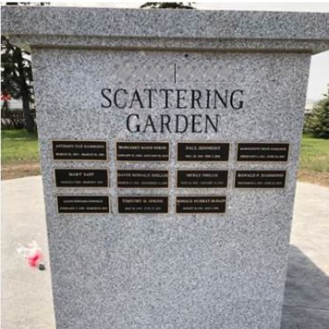
Sculpture | Any carving or other rendering of stone where all three dimensions (including depth) are used. | 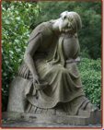
Slant | A rectangular, angled or sloped-top marker, cut at an angle, with or without a base. | 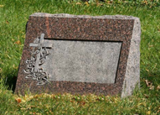
Tomb | A building for housing bodies or cremation urns (from one family or similar group) in separate drawers or compartments. | 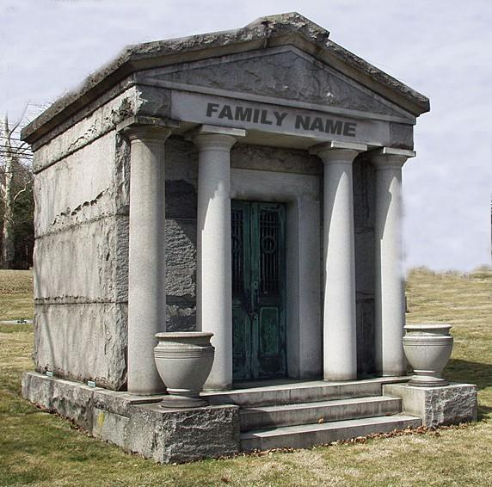
Upright | Tall, upright stone – most common type of stone (rectangular, upright). | 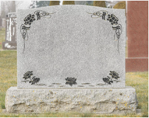
Vault | A tomb; a modern concrete shell placed over a coffin to prevent sinking of the ground surface in a cemetery. | 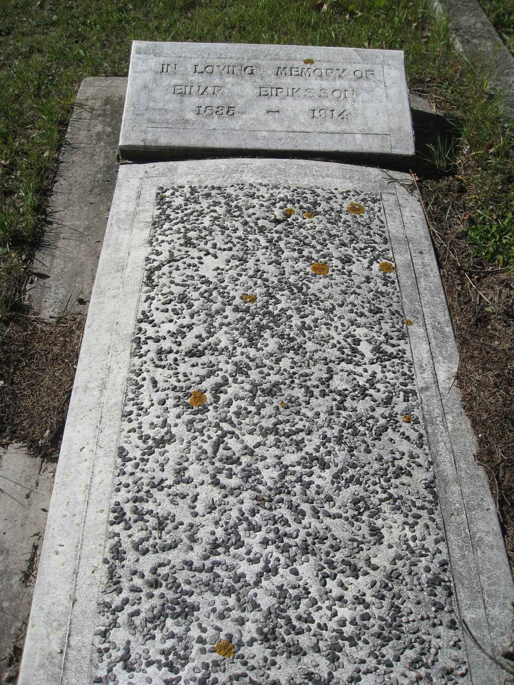
Wooden Cross | Cross made from wood. Is typically used to mark a grave by:  - Ethnic groups;  - Temporary use; or  - Years past. | 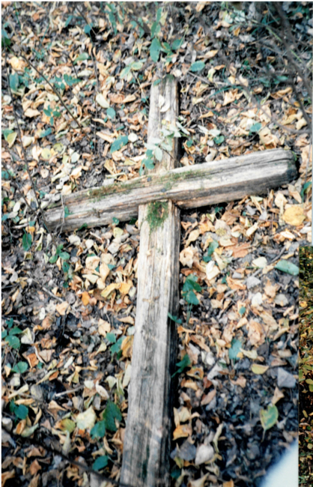

Appendix 2
PHOTOGRAPHY/IMAGE COPYRIGHT RELEASE

Date: ______________________________
To: Manitoba Genealogical Society
From: ______________________________ Phone # ______________________
ADDRESS: __________________________________________________________________
EMAIL: __________________________________________________________________
PHOTO(S)/IMAGE(S) DESCRIPTION/ID: ______________________________________________

I hereby represent that I am the exclusive owner of the photograph(s)/image(s) and I grant Manitoba Genealogical Society a non-exclusive, worldwide, royalty-free, unlimited, sublicensable and transferable license to exploit, and use of the photograph(s)/image(s) in whatever way necessary and suitable for the purposes of publication, broadcast, and promotion.
I waive all right over the photograph(s)/image(s) and understand the photograph(s)/image(s) may be cropped, altered, resized, modified, and/or reproduced for said purposes.
I give permission for uses, re-use, publish or republish, in whole or in part, in any medium for commercial, promotional or trade purposes.
Sincerely,
________________________________________
Signature (Photographer/Artist/Technician)

